
INDIGENOUS STUDIES RESEARCH SYMPOSIUM AND MASTERCLASS 2006
The Hall, Z Block, Cultural Studies Precinct, QUT Kelvin Grove Campus.

SYMPOSIUM 27th September
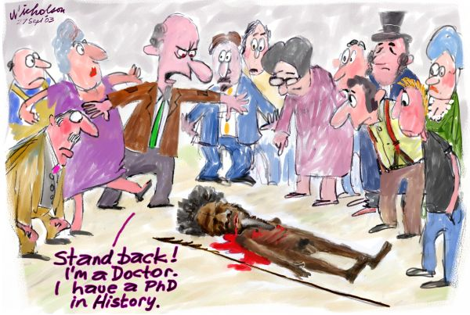
THE HISTORY WARS: FACTITOUS FICTION OR FICTIOUS FACTS?
In the past decade neo liberal politics has nourished a ‘debate’ played out within the media and the academy, which has become popularly known as the ‘history wars’. The leading personality in this debate is Keith Windschuttle and his work entitled: The Fabrication of Aboriginal History (2000). Several responses to Windschuttle have been mounted within the academy and public forums by Henry Reynolds, Robert Manne, Pat Grimshaw, Lyndall Ryan and Stuart Macintyre. The publication of several books have followed such as Robert Manne’s Whitewash: On Keith Windschuttle’s Fabrication of Aboriginal History (2003), Bain Attwoods’s Telling the Truth About Aboriginal History (2004) and Stuart MacIntyre and Anna Clark’s The History Wars (2005). This all - Indigenous symposium offers a different perspective on the ‘history wars’. Indigenous scholars will provide analyses and facilitate discussion about how the ‘history wars’ have impacted on Indigenous people and scholarship. Confirmed speakers include Professor John Maynard, Dr Irene Watson, Dr Wendy Brady, Dr Tony Birch, Associate Professor Tracey Bunda, Mr Greg Lehman, Mr Gary Foley, Ms Karen Martin, Ms Jean Phillips, Mr Victor Hart and Mr Phillip Falk.

INDIGENOUS STUDIES MASTER CLASS 28th and 29th September.
Session leaders include: Professor John Maynard, Professor Aileen Moreton-Robinson, Dr Wendy Brady and Dr Irene Watson. The Indigenous Studies Masterclass is aimed at postgraduates and early career researchers. Each of the session leaders will conduct a workshop to facilitate discussion on each participant’s research program. The master-class will provide opportunities for participants to undertake advanced study on issues surrounding research in the field of Indigenous studies and establish research networks for the future. Participants are expected to contribute actively to the Masterclass by actively discussing their current research or broader research program within workshops. A book of readings will be made available to participants.
Please see attached for registration details

INDIGENOUS STUDIES RESEARCH SYMPOSIUM AND MASTERCLASS 2006
REGISTRATION FORM

FAMILY NAME: |  | FIRST NAME:
MAILING ADDRESS:
Institution / Street 1
Street 2
Town/City
State and Postcode

PHONE: | EMAIL:
Special requirements (e.g. diet):

If you are intending to register for the Masterclass please list your research area of interest.

Please note that registration fees include: Morning and afternoon teas, lunches.
All pricing is inclusive of GST where applicable, and is given in Australian dollars.

“EARLYBIRD” RATES are applicable only to registrations received C.O.B. 31 July 2006 and registrations close on 31 August 2006.

REGISTRATION FEES
CATEGORY  HISTORY WARS SYMPOSIUM | COST | NUMBER OF REGISTRATIONS
Academic/Waged | Earlybird $165 (incl. 10% GST)
Academic/Waged | Full $220 (incl. 10% GST)
Student/Concession | Earlybird $110 (incl. 10% GST)
Student/Concession | Full $165 (incl. 10% GST)
MASTERCLASS AND  SYMPOSIUM | All attendees $350 (incl. 10% GST)
TOTAL: |  | $

¨ Please find enclosed my cheque/money order made payable to:
“The Queensland University of Technology” OR
¨ Please charge my Bankcard/Visa/Mastercard

CARD NUMBER
CARDHOLDER’S NAME (exactly as printed on card)
CARD EXPIRY DATE  ____/______ | Cardholder’s Signature:  ________________________________ Date: ____________
Amount charged (AUD$): | $

Please Note:
- The University reserves the right to reject any applications deemed by the University to not be in its best interest.
- The University only accepts MasterCard, Visa or Bankcard.
- Overseas bank cheques must be in AUD$ Australian Dollars, drawn on an Australian Bank and free of all charges.

PLEASE POST YOUR REGISTRATION TO
Professor Aileen Moreton-Robinson
C/- Centre for Learning Innovation
B Block Level 5
QUT
Victoria Park Road
Kelvin Grove Q4059

OR FAX TO

07 3864 3986

Convenor: Professor Aileen Moreton-Robinson
Email contact address: a.moreton-robinson@qut.edu.au

